**FLUTTER PROJECT-INKSOUL**

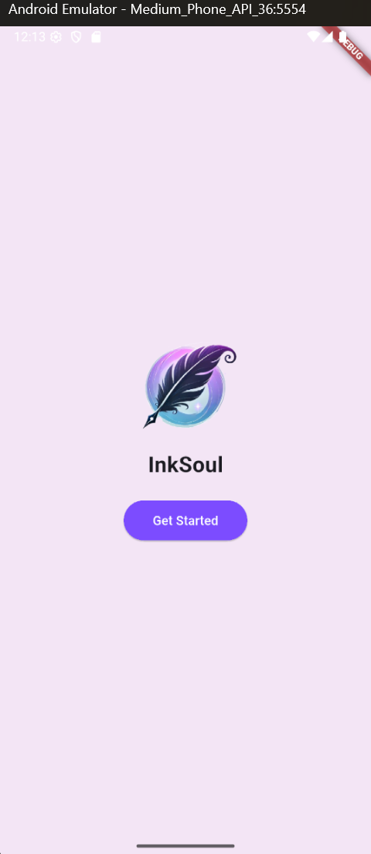

* InkSoul is a Flutter-based android journaling app that allows users to capture their daily thoughts, moods, and reflections in a seamless and intuitive interface.
* The app provides a rich writing experience while integrating features like mood tracking, quote inspiration, and bilingual support.
* Users can write, save, and revisit their past entries,and even delete unwanted ones.
* InkSoul leverages Firebase Firestore for secure data storage and retrieval, ensuring a smooth and synchronized experience across devices.
* The app's elegant UI, featuring a soothing purple theme, enhances the writing experience, making it an ideal companion for anyone looking to cultivate a journaling habit.

**1.Home Page**

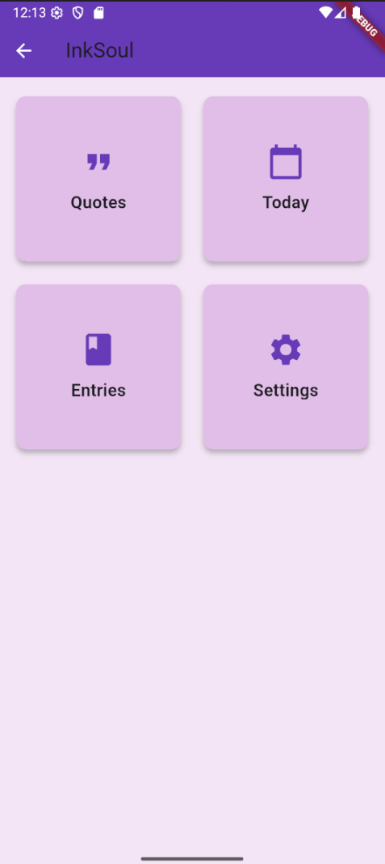

* Upon clicking **Get Started**, users are navigated to the **home page**, where they can explore the app's core features, presented as **card components** for an intuitive experience.
* The home screen consists of four main sections: **Quotes, Today, Entries, and Settings**.

**2.Quotes Page**

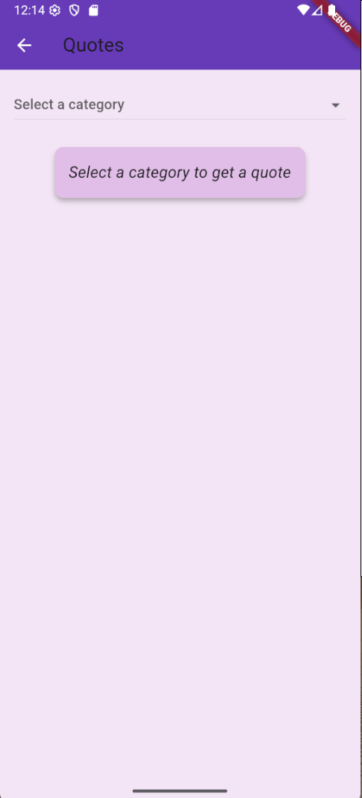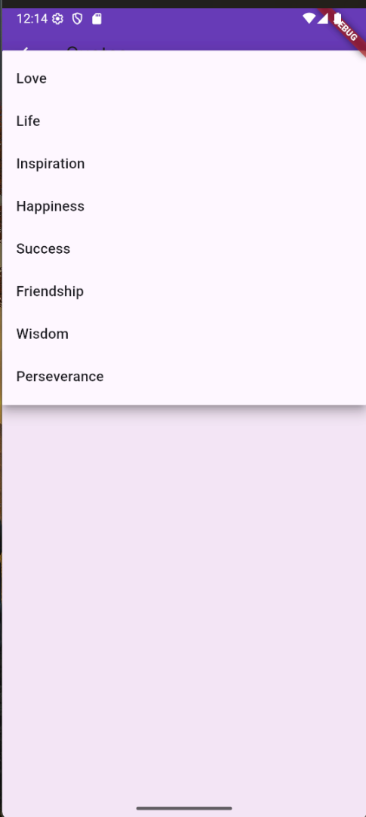

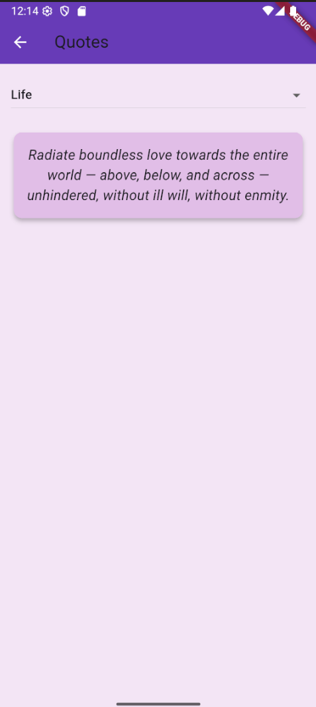

* The **Quotes** page features a **dropdown menu** that allows users to select from various **categories** such as love, life, inspiration, happiness, success, and more.
* Upon selecting a category, a **quote related to that theme is fetched** from an **external API** and displayed on the screen.
* This functionality enables users to discover meaningful and motivational quotes tailored to their interests.

**3.Today Page**

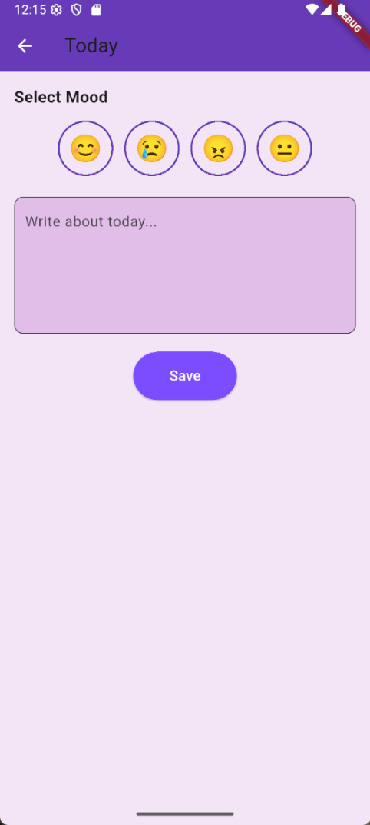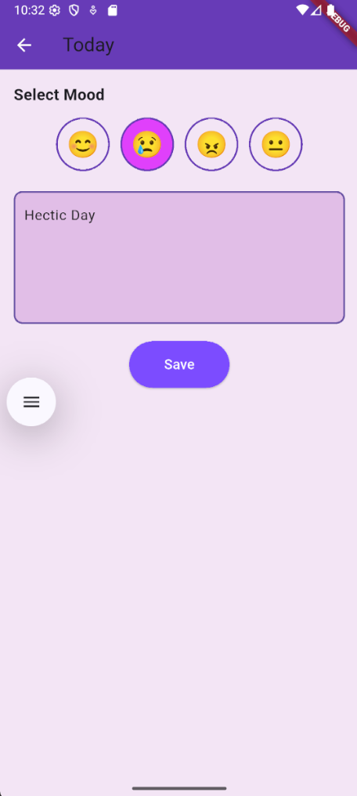

* The **Today** page allows users to **select their mood** from a set of predefined options and **write about their day** in a text entry field.
* This feature provides a simple and intuitive way for users to log their daily experiences and emotions.
* Once the entry is written and saved, it is **securely stored in the Firebase database**, ensuring that users can access their past reflections anytime.

**4.Entries Page**

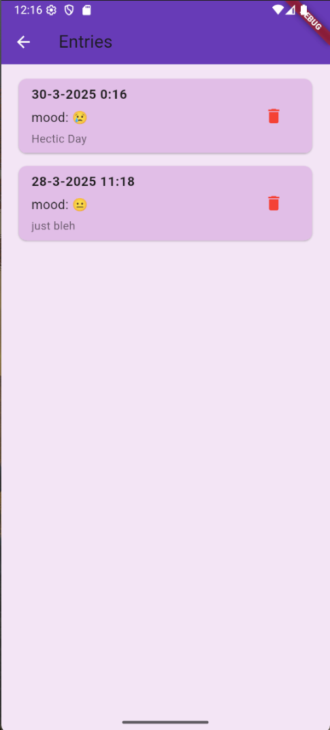

* The **Entries** page displays a list of all previous journal entries made by the user, **retrieved from the Firebase database**.
* Each entry includes the **date, time, selected mood, and written content**, allowing users to revisit their past reflections easily.
* Additionally, the page features a **delete option**, enabling users to remove an entry if desired.
* When an entry is deleted, the change is **instantly reflected in the Firebase database**, ensuring that the stored data remains up to date.

**Firebase Database Integration**

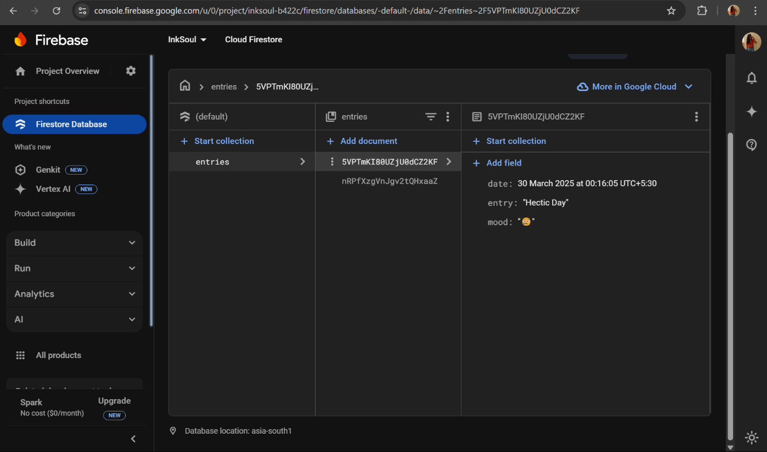

* When a journal entry is created and saved, it is securely stored in the **Firebase database**, allowing users to access their past reflections anytime.
* The Entries page retrieves and displays these stored entries dynamically from **Firebase.**
* Additionally, any modifications, such as deleting an entry, are instantly reflected in the **Firebase database**, ensuring that the data remains synchronized and up to date, providing a smooth and consistent journaling experience.

**5.Settings Page**

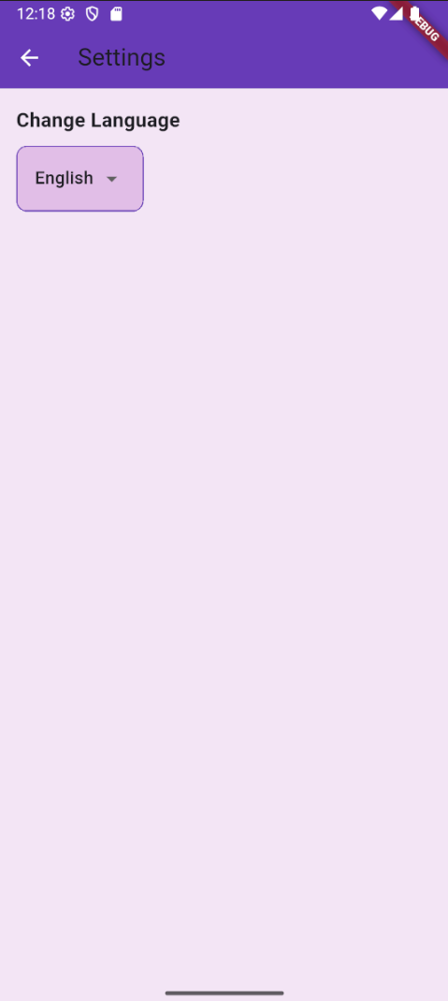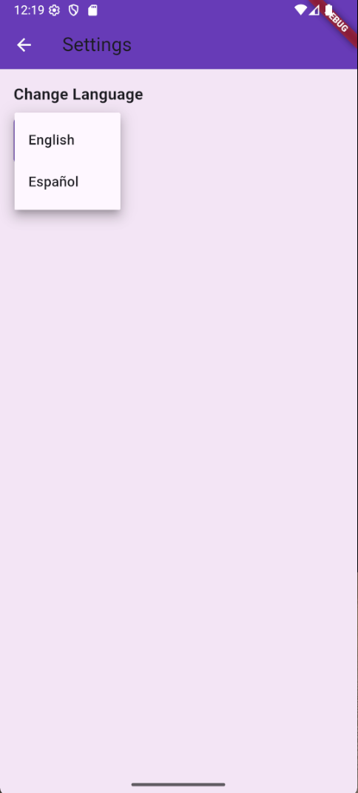

* The **Settings** page includes a **language selection feature**, allowing users to **switch between English and Spanish**.
* By default, the app is set to **English**, but users can **change the language using a dropdown menu**.

**Localization**

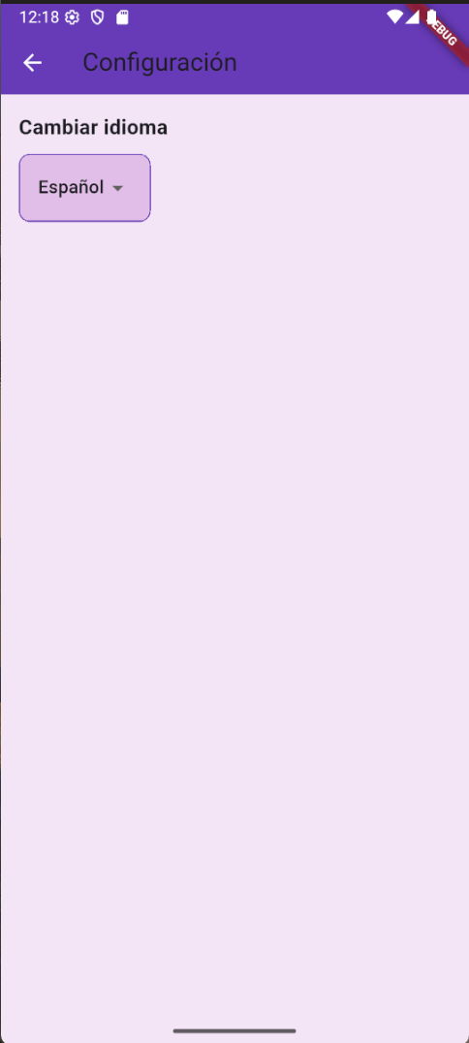

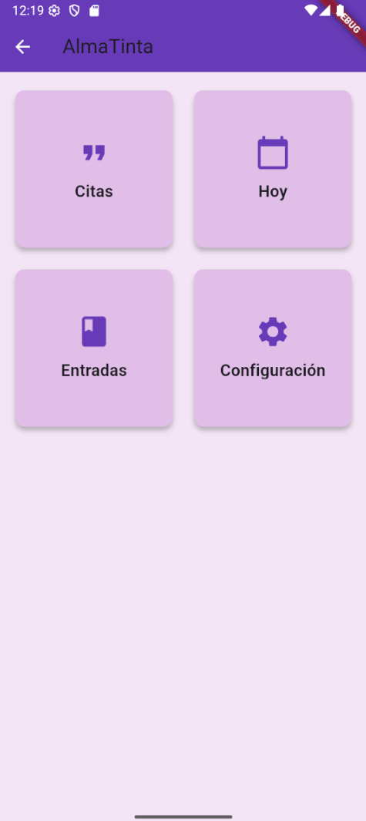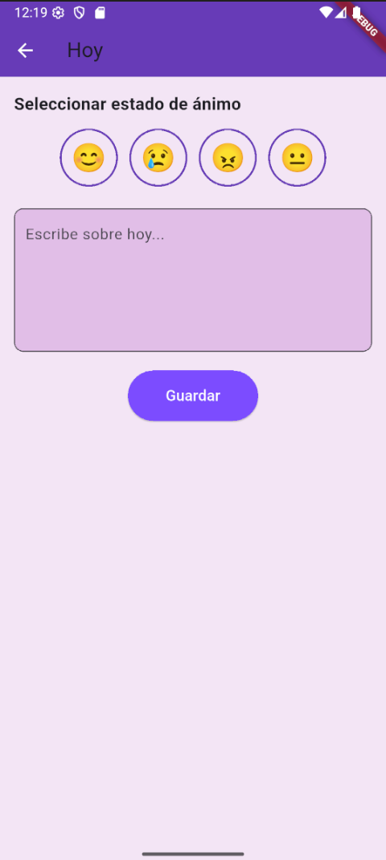

**Conclusion**

**InkSoul** project satisfies the conditions as follows:

* **Widgets** – Used various **Flutter widgets** for UI components (buttons, text fields, cards, etc.).
* **Stateless & Stateful Widgets** – Implemented both **stateless (EntriesPage)** and **stateful widgets (TodayPage)**.
* **Styling & Theming** – Used **AppColors** for consistent **theming and styling** across the app.
* **Layouts & Views** – Employed **Column, Row, ListView, and Card** for structuring different screens.
* **Navigation** – Implemented **navigation between screens** using Navigator.push() and pop().
* **Gestures** – Uses **GestureDetector** (e.g., mood selection in TodayPage) and **buttons** for user interactions.
* **API Calling** – Fetched **quotes from an external API** (quotable.io).
* **Database** – Stored user entries in **Firestore Database**.
* **Firebase Integration** – Used **Firebase Firestore** for **data storage and retrieval**.
* **Localization** – Supports **English and Spanish** with a **dropdown-based language switcher**.